Category 6A Shielded Keystone Jack

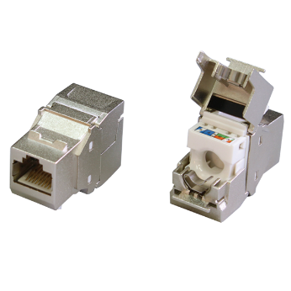

Category 6A shielded keystone jack supports the 10/100/1G BASE-T Ethernet, as well as advanced new 10G BASE-T Ethernet. The shielded jack with industrial leading transmission performance and provide exceptional level of headroom, meets and exceeds ANSI/TIA-568.2-D and ISO/IEC 11801 2nd edition Category 6A standards. Zinc-alloy metal shell balances/eliminates the Alien crosstalk while the data is at high speed transmission. Narrow width design fits 1U 24-port empty panel for most efficient use of rack space.

Features

Zinc-alloy metal shell

Tool-free, no additional tool required for termination

Contacts are phosphor bronze plated with 50 micro inches hard gold

Dual T568A &amp; T568B wiring

Polycarbonate 94V0 rated

Force EC Cat.8/Class I Channel certified

4PPoE compliant in accordance with IEEE802.bt Type 4

Ordering Information

|  |  |
| --- | --- |
| PART | Description |
| 1A68TPZA0 | RJ45, 8-Conductor Cat.6A , Tool-free, Shielded, 180 degree, H.D. version |
| 1A68IPZA0 | RJ45, 8-Conductor Cat.6A , 110 IDC, Shielded, 180 degree, H.D. version |
| 5A68TPZA0 | RJ45, 8-Conductor Cat.6A , Tool-free, Shielded, 180 degree, H.D. version |
| 6A68TPZA0 | RJ45, 8-Conductor Cat.6A , Tool-free, Shielded, 180 degree, H.D. version |
| 7A68TPZA0 | RJ45, 8-Conductor Cat.6A , Tool-free, Shielded, 180 degree, H.D. version |
| 1B68TPZA0 | RJ45, 8-Conductor Cat.6A , Tool-free, Shielded, 180 degree, H.D. version, fits 0.5U panel |
| 7B68TPZA0 | RJ45, 8-Conductor Cat.6A , Tool-free, Shielded, 180 degree, H.D. version, fits 0.5U panel |
| 0T68TPZA0 | RJ45, 8-Conductor Cat.6A , Tool-free, Shielded, 90 degree, H.D. version, fits 0.5U panel |
| 1T68TPZA0 | RJ45, 8-Conductor Cat.6A , Tool-free, Shielded, 90 degree, H.D. version, L=34.5mm, fits 0.5U panel |